Activity | Data Type
Number of beatings from Wife | Discrete
Results of rolling a dice | Discrete
Weight of a person | Continues
Weight of Gold | Continues
Distance between two places | Continues
Length of a leaf | Continues
Dog's weight | Continues
Blue Color | Discrete
Number of kids | Discrete
Number of tickets in Indian railways | Discrete
Number of times married | Discrete
Gender (Male or Female) | Discrete
Q1)Identify the Data type for the Following:

Q2)Identify the Data types, which were among the following
Nominal, Ordinal, Interval, Ratio.
Data | Data Type
Gender | Nominal
High School Class Ranking | Ordinal
Celsius Temperature | Interval
Weight | Ratio
Hair Color | Nominal
Socioeconomic Status | Ordinal
Fahrenheit Temperature | Interval
Height | Ratio
Type of living accommodation | Nominal
Level of Agreement | Ordinal
IQ (Intelligence Scale) | Ratio
Sales Figures | Ratio
Blood Group | Nominal
Time Of Day | Ordinal
Time on a Clock with Hands | Interval
Number of Children | Ratio
Religious Preference | Nominal
Barometer Pressure | Interval
SAT Scores | Interval
Years of Education | Ratio

Q3) Three Coins are tossed, find the probability that two heads and one tail are obtained?
ANS: The Probability of getting two heads and one tails in the toss of three coins simultaneously is 3/8 or 0.375.

Q4) Two Dice are rolled, find the probability that sum is
- Equal to 1
- Less than or equal to 4
- Sum is divisible by 2 and 3
ANS: a) The probability is zero because both dice start with 1(1,1)
b) the probability of getting a sum less than or equal to 4 is 6/36 = 1/6
(1,1) (1,2) (1,3) (2,1) (2,2) (3,1)
c) 6/36 =1/6
(1,5) (2,4) (3,3) (4,2) (5,1) (6,6)

Q5) A bag contains 2 red, 3 green and 2 blue balls. Two balls are drawn at random. What is the probability that none of the balls drawn is blue?

ANS: The probability is 5/7

Q6) Calculate the Expected number of candies for a randomly selected child
Below are the probabilities of count of candies for children (ignoring the nature of the child - Generalized view)
CHILD | Candies count | Probability
A | 1 | 0.015
B | 4 | 0.20
C | 3 | 0.65
D | 5 | 0.005
E | 6 | 0.01
F | 2 | 0.120

Child A – probability of having 1 candy = 0.015.
Child B – probability of having 4 candies = 0.20
ANS: 3.09

Q7)Calculate Mean, Median, Mode, Variance, Standard Deviation, Range & comment about the values / draw inferences, for the given datasets.
- For Points, Score, Weigh>
Find Mean, Median, Mode, Variance, Standard Deviation, and Range and Comment about the values/ Draw some inferences.
ANS:
Calculations | Points | Score | Weight
Mean | 3,596 | 3,217 | 17,848
Median | 3,695 | 3,325 | 17,17
Mode | 3,891 | 3,54 | 17,43
Variance | 0,285 | 0,957 | 3,19
Standard deviation | 0,534 | 0,978 | 1,786
Range | 2.79,4.93 | 1.513,5.424 | 14.5,22.9
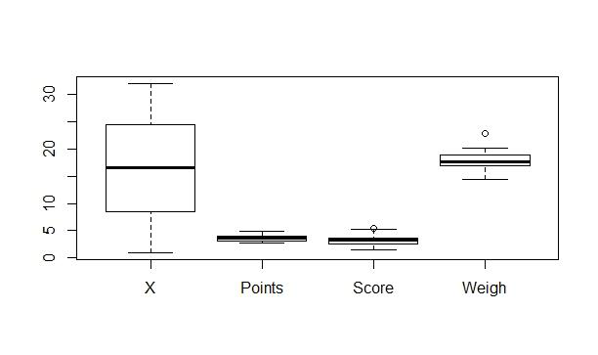

Q8)Calculate Expected Value for the problem below
- The weights (X) of patients at a clinic (in pounds), are
108, 110, 123, 134, 135, 145, 167, 187, 199
Assume one of the patients is chosen at random. What is the Expected Value of the Weight of that patient?
ANS: 145.333
Q9) Calculate Skewness, Kurtosis & draw inferences on the following data
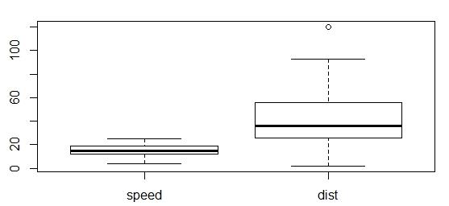
ANS: Car’s speed and distance
Index | Car speed | Distance
Skewness | -0,1139548 | 0,7824835
Kurtosis | 2,422853 | 3,248019

ANS: SP and Weight (WT)
Index | SP | Weight
Skewness | 1,581454 | -0,6033099
Kurtosis | 5,723521 | 3,819466

Q10) Draw inferences about the following box-plot & histogram
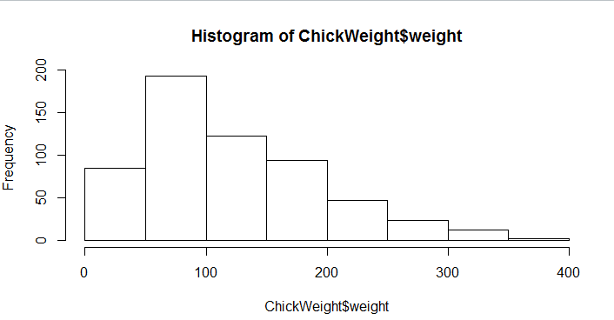

ANS: 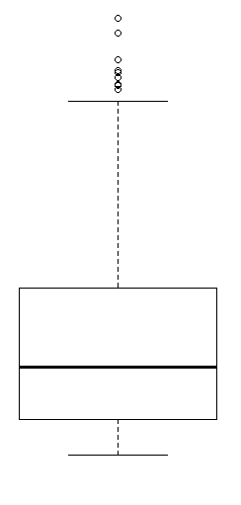
1)As it is right skewed the mean is greater than the median.
2)There are too many outliers, and they are at a distance from mean, median and mode.

Q11)Suppose we want to estimate the average weight of an adult male in Mexico. We draw a random sample of 2,000 men from a population of 3,000,000 men and weigh them. We find that the average person in our sample weighs 200 pounds, and the standard deviation off the sample is 30 pounds. Calculate 94%,98%,96% confidence interval?
ANS:
Confidence interval | Z value | Range
Interval at 94% | 1,880794 | 198.74,201.26
interval at 96% | 2,053749 | 198.62,201.38
Interval at 98% | 2,326348 | 198.43,201.56

Q12)Below are the scores obtained by a student in tests
34,36,36,38,38,39,39,40,40,41,41,41,41,42,42,45,49,56
- Find mean, median, variance, standard deviation.
- What can we say about the student marks?
ANS:
1)
Index | Value
Mean | 41
Median | 40,5
Variance | 25,52
Standard deviation | 5,05664

2) Mean is greater than median, it will be right skewed and without any outliers. Mass of the student’s marks lies between 38 and 42.
Q13) What is the nature of skewness when mean, median of data are equal?
ANS: Symmetric
Q14) What is the nature of skewness when mean > median?
ANS: Right skewed
Q15) What is the nature of skewness when median > mean?
ANS: Left skewed
Q16)What does positive kurtosis value indicates for a data ?
ANS: Positive kurtosis value indicates a thinner peak and wider tails.
Q17) What does negative kurtosis value indicates for a data?
ANS: Negative kurtosis value indicates a wider peak and thinner tails.
Q18)Answer the below questions using the below box-plot visualization.
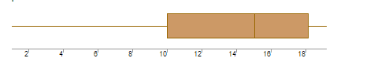
1) What can we say about the distribution of the data?
2) What is nature of skewness of the data?
3) What will be the IQR of the data (approximately)?
ANS:
- It is normally distributed.
- The data is left skewed.
- IQR= Q3-Q1
18-10=8

Q19)Comment on the below Box-plot visualizations?
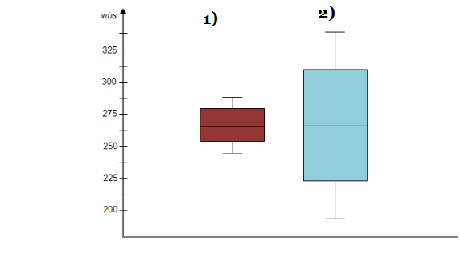
Draw an Inference from the distribution of data for Boxplot 1 with respect Boxplot 2.
ANS: Boxplot 1 and Boxplot 2 are normally distributed.

Q 20)Calculate probability from the given dataset for the below cases

Calculate the probability of MPG of Cars for the below cases.
MPG <- Cars$MPG
  - P(MPG>38)
  - P(MPG<40)
c. P (20<MPG<50)
ANS:
1) 1 - pnorm (38,34.422,9.13144) = 0.3475908
2) pnorm (40,34.422,9.13144) = 0.7293527
3) pnorm (50,34.422,9.13144) -(1-pnorm (20,34.422,9.13144))=0.01311818

Q 21)Check whether the data follows normal distribution
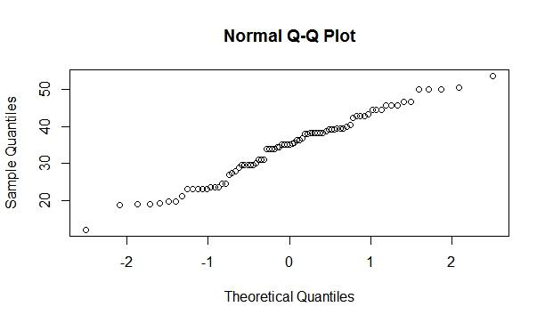
- Check whether the MPG of Cars follows Normal Distribution? ANS:

MPG of cars is normally distributed

b) Whether the Adipose Tissue (AT) and Waist Circumference (Waist)From wc- at data set follows Normal Distribution?
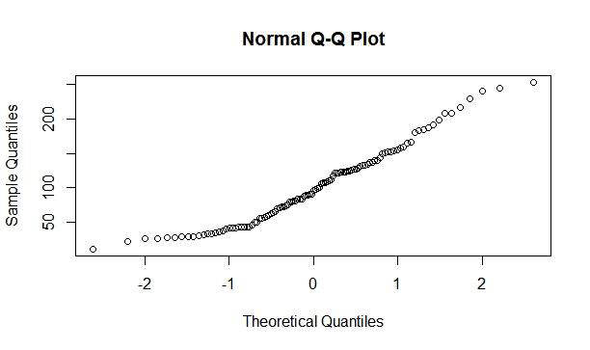
ANS:

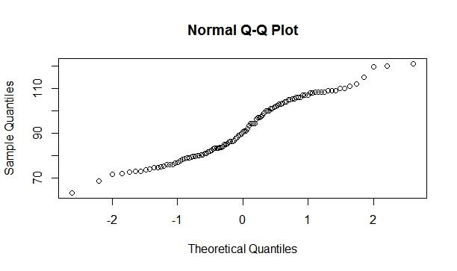
Adipose tissue (AT) is normally distributed

Waist circumference (WC) is normally distributed

Q 22) Calculate the Z scores of 90% confidence interval,94% confidence interval, 60% confidence interval?

ANS:
Confidence interval | Z scores
60 % | 0,8416212
90 % | 1,644854
94 % | 1,880794

Q 23) Calculate the t scores of 95% confidence interval, 96% confidence interval, 99% confidence interval for sample size of 25?
ANS:

Confidence interval | T scores
95 % | 2,063899
96 % | 2,171545
99 % | 2,79694

Q 24)A government company claims that an average light bulb lasts 270 days. A researcher randomly selects 18 bulbs for testing. The sampled bulbs last an average of 260 days, with a standard deviation of 90 days. If the CEO's claim were true, what is the probability that 18 randomly selected bulbs would have an average life of no more than 260 days
ANS:
Here
n= 18
x=260
Standard deviation=90
μ= 270
t=0.471
d.f(degrees of freedom) =(n-1) = 17
Probability = 0.3218

